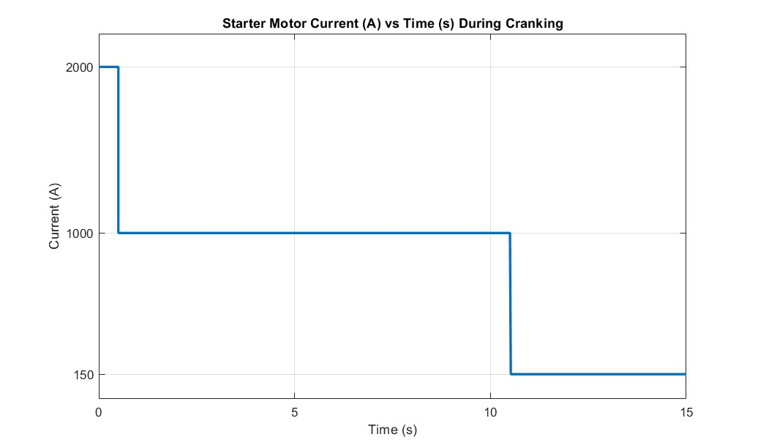
Cranking current 1000A lasting for less than 10 s
Inrush current 2000A lasting less than 1 s
Continuous load current 150 A demand after the engine starts

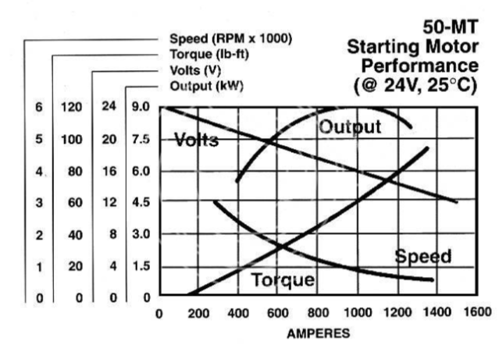
Max cranking current cut-off
Lowest battery voltage Input cut off

- 100 % DC = Continuous
- 60 % DC = 18 s ON, 12 s OFF
- 30 % DC = 9 s ON, 21 s OFF
- 25% DC = 7.5 s ON, 22.5 s OFF

=

A 120mm2 welding cable can only handle 830A for 9s
30% of a 30 second duty cycle means that the cable draws cranking current for 9 seconds and then cools for 21 seconds before another attempt.
